**UNIVERSITY OF NAIROBI**

**COLLEGE OF HUMANITIES AND SOCIAL SCIENCES**

**DPERTMENT OF GEOGRAPHY AND ENVRIRONMENTAL STUDIES**

**PROJECT PROPOSAL**

**RUBBY YUNIKE ABONGO**

**CO1/80982/2017**

**2022**

**EFFECTS OF URBAN –SURBURBAN MIGRATION ON THE KENYAN ECONOMY**

**– A CASE STUDY OF NAIROBI CITY**

Contents

Abstract 2

Introduction 3

Background study 3

Problem statement 4

Aims and objectives of the study 5

Justification for the study 7

Literature Review 8

Research methodology 9

References 10

# ABSTRACT

As cities continually grow and economies advance, so are the populations within these economies. The African pollution is expected to reach an approximate of 1.8 billion by 2025. Further the African Development bank alludes that the growth of the African population is equated to the per capita income of the various cities. Currently Nigeria is the leading currently in mass population at 206 million persons.

However majority of the population within these ranges falling within persons of age range 18-35 years of age. Cons

Frequently, this forms the highest workforce and a ready market for the job market. African Nations such as South Africa, Kenya, and Egypt are currently trying to put in enough measures to help absorb majority of this population into its industrial workforce for the growth of the economy. Not all African countries are within the growing economies are able to produce enough resources for the populace. According to the World Banks statistics, most of these economies still import food products from other nations. For instance, sugar is imported from Brazil, Mexico provides these states with maize, and beef from Texas and Fish from Asia and Northern Europe.

Since independence, most of these African states have been trying to build infrastructure that can support their economies and growth. Even though electrification and roads have gone way ahead in helping these economies to adapt successfully to the current demands of the growing population, a lot has been happening behind the scenes. For instance, cities like Cairo, Lagos, Nairobi and Cape Town have seen the development of real estate firms and estates to curb the high rising population that constantly moves into these cities.

As a result of this, there have also been higher growing needs for the services rendered for these population. In turn, business activities have thrived, hospitals and health care services have been established, and social communities like churches, political groupings and tribal activities have been established. The result of this is that these groupings and communities have led to the growth of incoming generating activities and streams. Businesses for instance that have been developed as s result of settlement within the cities have become a source of employment and revenue to both the government and the individuals who work for these corporates.

As a result of overpopulaton, the cities settlement are now becoming overpopulated, depleted in resources and now the focus of city settlement is no longer fun and city dwellers are now shifting their attention to the sub-urban regions in these countries. In this study the researcher goes out to establish some of the economic impacts of city urban to sub –urban migrations and some of the potential benefits, limitations, risks and opportunities within the Kenya economy and to be specific, Nairobi city.

# CHAPTER ONE: INTRODUCTION

Nairobi is home to several communities such as the Somalis, Luos, Luhyas and Kambas. Even though no specific community holds ownership for the city, most of these communities stay in designated or specific areas and regions within the city.

The population of the city has been growing exponentially. Currently the Kenyan population as is estimated by the Kenyan National Bureau of Statistics (KNBS), 2019, National Census estimated that the current population stands close to 47Million active persons. The study also revealed that majority of this population was between the ages of 18-35 years of age. Consequently, what this implies/implores is that, majority of this population is within the working force.

Over the years, this population has been moving from the rural villages and communities to the city to come and find jobs and greener pastures. Some also come to the city for their first time in order to learn in the various public universities and institutions, and after graduating, end up looking for jobs in the city, where they coincidentally become dwellers and contribute to the growing population of the city.

As they study, work and socialise, the form families and communities that together contribute to some of the largest parts of the economy. Some of the estates within Nairobi that have witnessed these scenario include Kawangrare, Eastleigh, South C, Ngara, Parklands and Umoja.

### 1.2 Background study

Prior to 1992, Nairobi city was known to be the closest haven for any affluent persons to live and dwell in. Government civil servant were known to have housing amenities in Kariaokor, Madaraka, Railways and Nyayo estate. These estates were initially peaceful, well maintained by the city Municipality and within reach of government services.

However, as the years went by, rules and regulations changed, private land developers began to populate these places and new structures and buildings began to come up in these regions and as a result, new city dwellers would prefer these new and affordable housing schemes. Other problems associated with the initial urban settlement houses included;

Water. The supply of water to these government houses went down and they so were the inhabitants who now preferred to settle in new schemes and exit these ones. Another problem associated with these settlement schemes is the lack of maintenance by the responsible government agencies. This situation was worse and saw majority of these houses exited by their tenants to the newly established buildings and apartments. Enmass, the movement saw majority of these new apartments being occupied by both government civil servants and fresh city dwellers. Examples of estates and areas within the city where this happen include Buruburu in Jogoo Road, Langata, Westland and some parts of Thika road like Kasarani.

Since the rate of emigration and rural urban has also been on the rise, these city dwelling places have become overcrowded, less secures and have run short of certain social amenities like water and maintenances by both the government and their private owners.

## 1.3 Problem statement

With the increased movement of persons from other cities within the county like Kisumu, Mombasa and Nakuru, the population within Nairobi City has been growing significantly. Family sizes have increased, employment within the city has also gone higher, post the 2008 recession, the rate of unemployment went higher, leaving many city dwellers unable to pay their rent and move in with their fellows and together pay their rent. In that line, most of these city dwelling places turned out into silent ghettos where the inhabitants were now composed of low income individuals and small vendor retail business, corroding the whole picture of what one would have expected of a normal city resident.

Moreover, insecurity grow logistically and the crime rates also went higher. Buglers, muggers and robbers would occasionally attack these residents and rob them of their little possession. Some of these city dwellers could be even be contained by the local law enforcement officers.

Illegal drug dealers also sprung up in these city neighbourhoods. These drug dwellers morally corroded the decades of the initial dwellers of these city populace and as such the picture of these regions were tainted and blurred.

Over the years, private investors have discovered that city life is not so fulfilling as majority of these city dwellers are looking for secure, private, and social amenities neighbourhoods. The Growth of sub urban estates in regions like Kitengela, Ruiru, Kikuyu, Ngong, Kiserian, Athi River, Kamulu, Ruai, Utawala, Limuru have seen these city dwellers move out and build or buy land and housing in these place. This research study shall explore the various benefits, limitations, risks and opportunities associated with this movement.

# CHAPTER TWO: AIMS AND OBJECTIVES OF THE STUDY

The following aims and objectives are associated with this study

1. To determine the rate of movement of persons from urban to sub-urban areas within Nairobi city
2. To establish the features of suburb settlements in Nairobi City
3. To establish the effect of urban-sib –urban regions within Nairobi city
4. To establish the opportunities, limitations, risks associated with Urban- Sub-Urban movements within Nairobi City
5. To identify the future status of Urban-Sub Urban movements in Nairobi City

## 2.1 Hypotheses of study

The following are some of the the hypotheses related to this study;

1. Urban –Sub Urban migration has brought about economic value to the Kenyan economy
2. Urban –sub Urban urban migration trend is likely to increase in the near future
3. More business are likely to grow as a result of urban sub urban migration.
4. Sub urban dwellers are some of the highest contributes of the Kenyan economy

## 2.2. Justification for the study

This study is significant a number of ways:

The findings from this study can be utilised by the private developers to establish the market trend within the Sub urban areas. This level of information can be applied by private developers to know how to plan and organise their business in other regions.

This research can be utilised by other research scholars in doing studies in this industry to understory to understand the implicating effects of urban –sub urban migration. Researchers can do this by building on the knowledge that is already gained and established. This will be done by building on some of the missing blocks and patterns from this study.

The findings of this study will be used by the Nairobi City management to help plan the city population knowing very well which citizens live in which regions and what social status they fall into.

Once the findings from this research have been published, future possible city dwellers will use this information a guide into city settlement supposing they want to move into the city.

# CHAPTER THREE: LITERATURE REVIEW

According to research studies done by Oliveira & Pinho, P. (2010), urban planning practices in Kenyan have been formulated to address the ever growing population. Some of the issues discussed in this papers included drainage systems, electrification and the road system networks. The paper also discusses some of the challenges that have faced urban planning activities since the post-colonial stages in Kenya.

These challenges included the ever growing population in urban centers, lack of proper administration both from national government and the municipal governments. The paper however lays emphasis on the need to continuously review the existing urban planning policies to include /cater for room for future room for changes in the urban regions such as transport activities and traffic management.

In another study done by Barton & Catherine (2013), highlights the major cross cutting significance that need review in the Urban and Sub urban regions. Urban centers for a long time have been haven for majority of the city dwellers given their close proximity to work places, government offices and other social amenities such as hospitals and malls. The study highlights that in order for a healthy urban co-existence to be achieved / there needs to be also an existing and thriving sub-urban ecology. Whereas majority of the population will grow the urban set ups, the sub-urban centers /regions will advance and improve the economy of the urban environments.

Dynamic analysis of the urban economy reveals that urban business and economic activities are some of the most national revenue driving activities. These activities include transportation services, retailing services, private business entities and government corporations.

However, with the increased growing and demand for some of the services offered by these entities, these business are now establishing branches out of the urban centers into sub urban regions where they can also be accessed by the large population of individuals who have migrated from the active city life into these sub urban areas, Miyao (1981).

In another study done by On’ganya (2020), real estate and private land developers are shifting their attention towards developing more and more within their sub urban areas. These areas have not been widely explored and developed and as such are more preferred by the upper class urban dwellers. Some of these sub urban areas within Nairobi city are rapidly growing in mas and are the center of attraction for most of these population.

# 

# CHAPTER FOUR RESEARCH METHODOLOGY

The researcher aims to use publicly available data from the department of Kenya National Bureau of Statistics and also data from the Ministry of Planning and urban planning. These targeted datasets shall contain data on population of the urban as well as the populations for the sub urban regions.

The researcher will use R studio as the IDE for data analysis and data programming. The findings will be presented in graphs, charts tables.

# CHAPTER FIVE: DATA ANALYSIS

Data collection

The researcher identified two main methods of data collection that include:

* Questionnaire
* Observations

Since the objectives of the research study included figuring out how the migration form the urban to the sub –urban areas have in any way affected the population in these areas, and as such some of the data collected from the respondents included their lifestyle, economic activities and some of the primary assets that they owned. These assets included houses, vehicles and land in these areas.

Data cleaning:

A total of 100 responds were contacted during the research study and they gave their responses accordingly filling all the variables that included:

* zone_id
* zone_name
* estate_id
* population
* busy?
* status
* employed
* business
* infratsructure
* housing
* second_home

Each and every variable in the dataset represents something to the researcher. The zone id represents the identifier associated with the zone, for instance Ngong or Kikuyu. The East id is the unique identifier of the different estates where the researchers used to stay before moving to their new sub-urban areas. The population variable defines the exact population count of the particular area, and whether it’s a busy environment or not. The status variable spells out the satisfactory nature of the area, compare to how the residents view it. The study also focused on whether the respondents of these studies were employed or not and what is it in particular that they did for a living. Lastly, this research also sought to establish whether this was their first or second home.

The researcher then proceeded to remove outliers from the data, blank spaces and mixed variables types from the data. The results were as shown below:

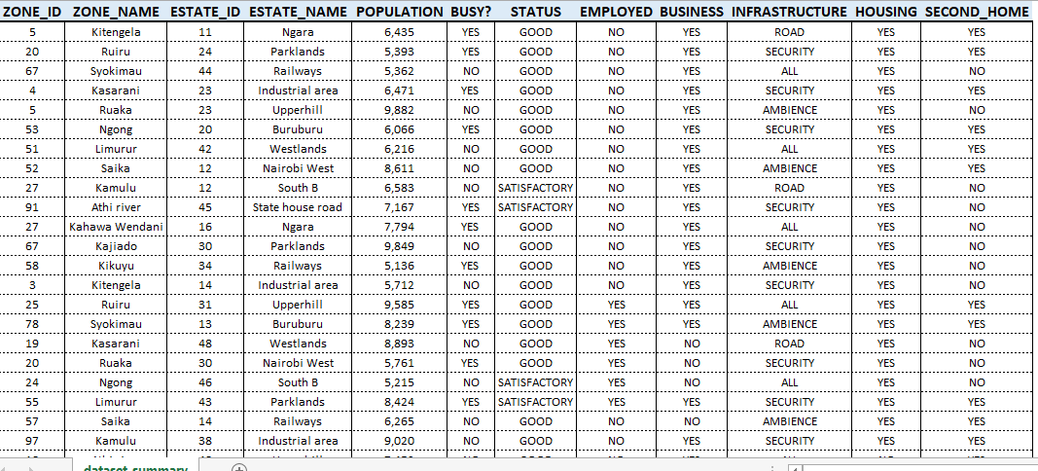

Data analysis

The first step is to get the summary of our data from the given 100 respondents as below:

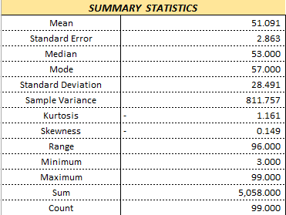

The standard deviation value from this dataset is 28.491, we shall use this value to determine the relationship of our dataset variables.

**Population zone summary**

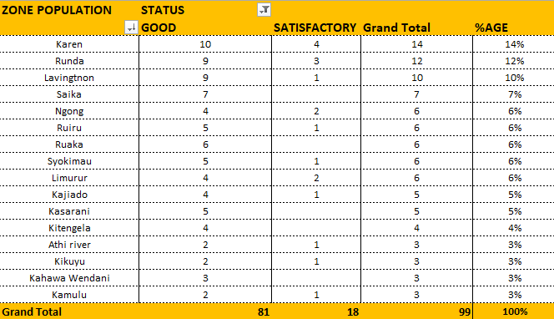

In terms of the population zone summary of the respondents, above 30% of the respondents chose the leafy sub-urban areas of Karen, Runda and Lavington, and chose them as good.

**Cause of migration**

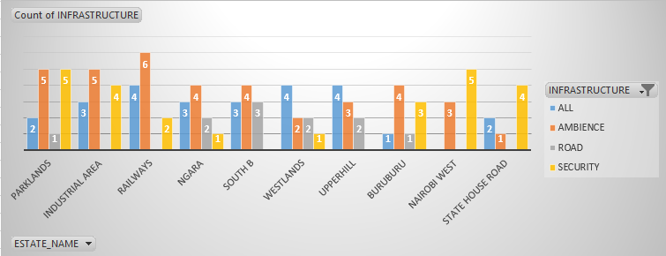

Most of the respondents who initially lived in Parklands, Industrial area and Ngara moved to these sub- urban areas due to the ambiance that was being poised in these regions. That has to be with the air trees and calmness in most of these locations. Second cause of these movements were attributed to the security present in most of these locations.

**Economic impacts of these migrations:**

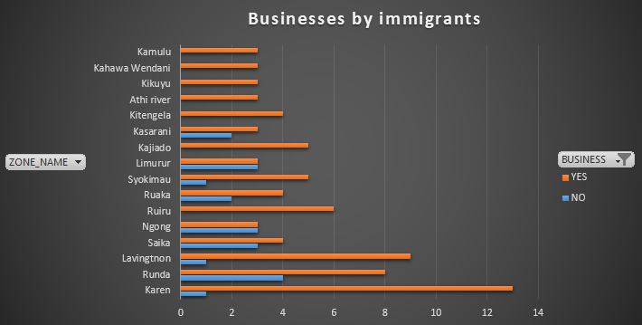

To understand whether the urban sub-urban migrations, it was realised from the analysis that most of the migrants had businesses running. The implication is that the establishments of these businesses would eventually incur gross national income and offer employment opportunities to so many young people to grow the economy.

### SUMMARY AND CONCLUSIONS

Whereas city population and life is good, it comes with its own challenges. Unlike today, the latter years of 1960s to the late 1990s, saw many people value Ngara, Parklands, South B and Railways. Overtime, population has since grown in these areas and certain essential services such as water, electricity and security are now hindered. To make it worse, these facilities are no longer maintained by their owners or just total neglect.

The effect of which has seen several members of these populations move to the greener sub-urban areas away from the city. Some of these areas/zones include Ngong, Athi River, Karen, Runda and Juja areas. Some of the reasons for these migrations include the ambience offered by these regions, security and the road network systems.

### Research recommendations:

The government should repair and regularly maintain these infrastructural facilities regarded as the home of city dwellers. These dwellings are regarded as the springer to the later sub-urban life.

The government should crate the whole process of opening and establishing a business process easier to allow for the growth of businesses established by these migrants.

# 

# References

Oliveira, V., & Pinho, P. (2010). Evaluation in urban planning: Advances and prospects. *Journal of Planning Literature*, *24*(4), 343-361.

Barton, Hugh, and Catherine Tsourou. *Healthy urban planning*. Routledge, 2013.

On’ganya, D. O. (2020). *THE EFFECT OF LAND USE PLANNING ONECONOMIC VULNARABILITY TO DISASTERMANAGEMENTINLOW INCOME NEIGHBOURHOODS OFELDORET URBAN AREA, KENYA* (Doctoral dissertation, MMUST).